**FESTNEST**

**A Project Report submitted in partial fulfillment of the requirements for the award of the degree of**

**MASTER OF COMPUTER APPLICATIONS**

**Submitted by**

**CHIPPADA LAKSHMANA RAO**

**(20L31F0012)**

**Under the esteemed guidance of**

**Prof. Dr. B. Prasad**

**Training & Placement Dean, VIIT.**



**DEPARTMENT OF MASTER OF COMPUTER APPLICATIONS**

**VISAKHAPATNAM**

**2020-2022**



**DEPARTMENT OF MASTER OF COMPUTER APPLICATIONS**



**CERTIFICATE**

This is to certify that the Project report entitled **“FESTNEST”** is a Bonafede record of project work carried out under my supervision by **CHIPPADA LAKSHMANA RAO** bearing Regd. No : 20L31F0012 in partial fulfillment of the degree of Master of Computer Applications of Vignan’s Institute of Information Technology(A) affiliated to Jawaharlal Nehru Technology University Kakinada, during the academic year 2020-2022.

Signature Signature

**NAME OF THE GUIDE** **HEAD OF THE DEPARTMENT**

Prof. Dr. B. Prasad Prof. Dr. G. Rajendra Kumar

Training & Placement Dean, VIIT. Department of IT, VIIT

**EXTERNAL EXAMINER**



**DEPARTMENT OF MASTER OF COMPUTER APPLICATIONS**

**VISAKHAPATNAM**

**2020-2022**

**DECLARATION**

I here by declare that this project report entitled **“FESTNEST”** has undertaken by me for the fulfillment of Degree in Master of Computer Applications. I declare that this project report has not been submitted anywhere in the part of fulfillment for any degree of any other University.

Place : Visakhapatnam CHIPPADA LAKSHMANA RAO

Date : (20L31F0012)

**ACKNOWLEDGEMENT**

An endeavor over a long period can be successfully with the advice and support of many well-wishers. I take this opportunity to express our gratitude and appreciation to all of them.

I express my sincere gratitude to my internal guide, **Prof.B.Prasad** for his encouragement and cooperation in completion of my project. I am very fortunate in getting the generous help and constant encouragement from him.

I would be very grateful to our project coordinator, **Mrs.A.Sirisha**  for the continuous monitoring of my project work. I truly appreciate for her time and effort spent.

I would like to thank our Head of the Department, **Dr.G.Rajendra Kumar** and all other teaching and non-teaching staff of the department for their cooperation and guidance during my project.

I sincerely thank to **Dr.B.Arundhati,** Principal of VIGNAN’S INSTITUTE OF INFORMATION TECHNOLOGY (A) for her inspiration to undergo this project.

I wanted to convey my sincere gratitude to **Dr.V.Madhusudhan Rao**, Rector of VIGNAN’S INSTITUTE OF INFORMATION TECHNOLOGY (A) for allocating the required resources and for the knowledge sharing during my project work.

I extended my grateful thanks to our honorable Chairman **Dr.L.Rathaiah** for giving me an opportunity to study in his esteemed institution.



**DEPARTMENT OF MASTER OF COMPUTER APPLICATIONS**

**VISAKHAPATNAM**

**2020-2022**



**VISION :**

* We aim to generate groomed, technical competent and skilled intellectual professionals.
* We serve as a valuable resource for modern industry and current society.

**MISSION:**

* Providing strong theoretical and practical knowledge in computer science discipline with an emphasis on software development.
* To provide need based quality training in the field of information technology.
* Impart quality education to meet global standards and achieve excellence in teaching-learning and research.
* To provide students with the tools to become productive, participating global citizens and life-long learners.



**DEPARTMENT OF MASTER OF COMPUTER APPLICATIONS**



**PROGRAMME OUTCOMES**

At the end of the programme the student shall be able to

* Application of Engineering Knowledge
* Problem analysis
* Design development of solutions
* Conduct investigation of complex problems
* Modern tool usage
* The engineer and society
* Environment and sustainability
* Ethics
* Individual team work
* Communication
* Project management and finance
* Lifelong learning

|  |  |  |
| --- | --- | --- |
| **S. No** | **Content** | **Page No** |
| 1 | Abstract | 2 - 3 |
| 2 | Introduction | 4 - 5 |
| 3. | Literature Survey (list of papers referred) | 6 - 7 |
| 4. | System Analysis  4.1 Existing System  4.2 Proposed System | 8 - 9 |
| 5. | System specifications  5.1 Functional Requirements  5.2 Software requirements  5.3 Hardware requirements | 10 - 15 |
| 6. | System Design  6.1 System Architecture  6.2 UML Diagrams  6.3 Data Flow Diagram | 16 - 22 |
| 7. | System Implementation  7.1 Project Modules  7.2 Source Code | 23 - 46 |
| 8. | System Testing  8.1 Testing Methods  8.2 Test cases | 47 - 51 |
| 9. | Experimental Results | 52 - 57 |
| 10. | Conclusion & Future scope | 58 - 59 |
| 11. | References | 60 - 61 |

**INDEX**

**CHAPTER – 1**

**ABSTRACT**

**1. ABSTRACT**

**Title: FESTNEST**

Booking websites are becoming more common today to reduce the requirement of intermediaries. Previously, when students and faculty members of different colleges wanted to attend an event in Vignan, say a fest, or a workshop, they would have to go through a dozen contacts to find the person in charge of selling passes. As if that was not hard enough, they would then have to hunt for that person all over the vast campus, which was extremely tiring and time-consuming.

For all these obstacles we are facing, we have come up with a solution named "FESTNEST". FESTNEST is a website created by student of VIIT to make it easier for students to buy tickets to college events like fests, workshops, cultural events etc. which take place on campus. We focus on providing fast and easily accessible services to students of different colleges interested in attending VIGNAN events.



The project aims to give the customers reasonable prices for event tickets with fast and high-quality services. It helps people who are looking for event tickets in VIGNAN. FESTNEST is the fastest way to buy tickets without getting tired. FESTNEST provides you with the most convenient way to book tickets for the events in VIGNAN. All you need to do is go to the website FESTNEST, where you have to register or log in with any of the social logins provided over there, after which you can pick the desired event you want to attend, with quick payment.

**CHAPTER – 2**

**INTRODUCTION**

**2. INTRODUCTION**

The project objective is to book events or fest tickets online. The FestNest is an Internet-based application that can be accessed throughout the Net and accessed by anyone who has a net connection. This application will reserve the tickets. This online ticket reservation system provides a website for event organizers where any internet user can access it. The user must login to the system and needs a credit card/debit card/UPI for booking the tickets. The website provides complete information regarding currently running events with details of event timings, available seats.

This newly designed website is a faster, cleaner, and more personal website, specially designed to make your booking experience better. Logon, navigate and find out for yourselves, and if you are stuck somewhere or get doubts that must be cleared, we provided an option called Contact Us.

Customers may view the contents of any event or fest at any time and may book any ticket as needed. The program automatically calculates the subtotal and grand total. When a visitor decides to finally book the ticket, the order information, including the buyer's name and billing instruction, is stored in the database securely, and payment has been made. You need to register a new user whenever you have first visited or site. Then in the future, it will be stored in our database permanently, and you can book the event tickets at any time you want with this username and password.

**CHAPTER – 3**

**LITERATURE SURVEY**

**3. LITERATURE SURVEY**

People who want to attend VIGNAN events (like fests, workshops etc.) can visit this website search for the events which they want to attend through FESTNEST. Many people who wanted to attend the events in VIGNAN could not attend just because they did not have any clear idea of what will be done in that event and where to or how to buy the tickets.

So here, the FESTNEST website gives the person a clear idea of the events, technical and non-technical, the price of the passes, the activities planned in it, the organizers, guests etc.

No one has ever thought or implemented it yet, so we came up with the idea of creating a website to buy VIGNAN event tickets online through the FESTNEST website.

**CHAPTER – 4**

**SYSTEM ANALYSIS**

**4. SYSTEM ANALYSIS**

**4.1 EXISTING SYSTEM :**

Existing system event management is manual. In this system, all work is done by manually so it can take more time to complete event-related work. So it is difficult to manage all event activity manually. In the existing system does not help users to get the right information at the right time.

**4.2 PROPOSED SYSTEM :**

The proposed system is computerized and has been developed using PHP, HTML, CSS, therefore it gives more facilities than the present system. It provides quick access to any data that is stored in the database. In this system, the user has to enter the data only once and then it will get stored in the database which gets linked with all files. This reduces the workload of the user and it is also a time saving process. The information about any event can be retrieved easily whenever required. The system maintains all records easy. The proposed system consists of different packages (in terms of cost range) for each category of events. The package contains all the facility such as décor, entertainment, catering etc. as per the range of the package.

**CHAPTER - 5**

**SYSTEM SPECIFICATIONS**

**5. SYSTEM SPECIFICATIONS**

**5.1 FUNCTIONAL REQUIREMENTS :**

**5.1.1 VISUAL STUDIO :**

Visual Studio Code Text Editor is a full-featured Text editor for editing local files or a codebase. It includes various features for the editing code base, which helps developers to keep track of changes. Various features that Visual Studio supports are as follows −

* + - Syntax Highlight
    - Auto Indentation
    - File Type Recognition
    - Sidebar with files of the mentioned directory
    - Macros
    - Plug-in and Packages

The Visual Studio Text editor is used as an Integrated Development Editor (IDE) like Sublime and NetBeans. When you use a suitable Text editor, you can enjoy its rich beneficial features. Sublime Text offers its users the following benefits −

* + - Ability to solve linker errors.
    - Keeping track of all files and folders to work with.
    - Connectivity with version control systems like Git, Mercurial.
    - Problem-solving capabilities.
    - Keeping color combination for syntax combination.

**5.1.2 XAMPP :**

XAMPP is an abbreviation where X stands for Cross-Platform, A stands for Apache, M stands for [*MYSQL*](https://www.javatpoint.com/mysql-tutorial), and the Ps stand for PHP and Perl, respectively. It is an open-source package of web solutions that includes Apache distribution for many servers and command-line executables and modules such as Apache server, [MariaDB](https://www.javatpoint.com/mariadb-tutorial), PHP, and Perl.

XAMPP helps a local host or server test its website and clients via computers and laptops before releasing it to the central server. It is a platform that furnishes a suitable environment to test and verify the working

of projects based on Apache, Perl, MySQL database, and PHP through the host's system. Among these technologies, [Perl](https://www.javatpoint.com/perl-tutorial) is a programming language used for web development, [PHP](https://www.javatpoint.com/php-tutorial) is a back-end scripting language, and MariaDB is the most vividly used database developed by MySQL.

**5.2 SOFTWARE REQUIREMENTS :**

**5.2.1 HTML :**

HTML stands for "Hyper Text Markup Language", which is a programming language. The word HTML has two parts. The first is **Hypertext**, which means" clickable" Markup Language means representing things or indicating things. To sum up, HTML is a programming language and contains hyper (**clickable**) Text. That is to say, HTML is the foundation of web development. We can see on any web page the page source. Thus, this page source indicates the whole structure of a web page in HTML coding. HTML is built by codes. HTML with its partners makes a [web](https://www.sunsoftworld.com/how-to-create-your-own-website/)page fully functional and attractive. The HTML, for instance, emphasize on

* + - Defines the size of the Text.
    - Defines the shape/ font style of the Text.
    - Aligns the Text in different portions/ Directions.
    - Arranges the Text in tabular form.
    - Refers page viewers to the next page.
    - Supports images so, you can display them on the web page.
    - Supports videos too.
    - With the help of Java, it performs calculations and
    - Performs conditional tasks.
    - Can embed different scripts in itself to perform complicated tasks

**5.2.2 CSS :**

CSS stands for Cascading Style Sheets. It is the coding language that gives a website its look and layout. Along with HTML, CSS is fundamental to web design. Without it, websites would still be plain Text on white backgrounds.

CSS is one of the most powerful tools in a web designer's arsenal. With it, you can drastically alter the entire mood and user experience of a website.

Benefits you will find using CSS are:

* + - Freedom to position HTML elements anywhere on a web page while allowing you to keep your markup (HTML) clean and organized.
    - Ability to adjust for differences in the way browsers render a web page.
    - Endless customization options to a web page including fonts, colors, borders, hover and transition effects, etc.
    - Ability to easily create, update and maintain styles simultaneously for a large number of web pages.
    - Ability to use media queries and relative units (ems and %s) to create web pages that adapt to the user's screen size—ideal for creating mobile responsive web pages.

**5.2.3 JAVASCRIPT :**

JavaScript is a text-based programming language used both on the client-side and server-side that allows you to make web pages interactive. JavaScript is mainly used for web-based applications and web browsers. But JavaScript is also used beyond the Web in software, servers and embedded hardware controls. JavaScript allows users to interact with web pages. There are almost no limits to the things you can do with JavaScript on a web page

* + - Show or hide more information with the click of a button
    - Change the colour of a button when the mouse hovers over it
    - Slide through a carousel of images on the homepage
    - Zooming in or zooming out on an image
    - Displaying a timer or count-down on a website
    - Playing audio and video in a web page
    - Displaying animations

**5.2.4 BOOTSTRAP :**

Bootstrap is an HTML, CSS, and JavaScript front-end framework. It is a platform for creating responsive, mobile-first websites. With some HTML and CSS fundamentals knowledge, you can use Bootstrap's premade templates to build Bootstrap types, tables, buttons, typography, navigation, modals, image carousels, and optional JavaScript plugins.

Bootstrap's features are sensitive, which means they adjust to the size of the device you're using to view the page, whether it's a desktop, laptop, or smartphone. When viewed from an itinerant, a Bootstrap type on a desktop site, for example, will proportionally shrink in size. Mobile-first designs, as opposed to desktop-first designs, are part of Bootstrap's core structure, as previously mentioned.

**5.2.5 PHP :**

PHP (Hypertext Preprocessor) is known as a general-purpose scripting language that can be used to develop dynamic and interactive websites. It was among the first server-side languages that could be embedded into HTML, making it easier to add functionality to web pages without needing to call external files for data.

Following are the main features of PHP:

* + - PHP performs system functions, i.e. from files on a system, it can create, open, read, write, and close them.
    - PHP can handle forms, i.e. gather data from files, save data to a file, through email you can send data, return data to the user.
    - You add, delete, modify elements within your database through PHP.
    - Access cookies variables and set cookies.
    - Using PHP, you can restrict users to access some pages of your website.
    - It can encrypt data.

**5.2.5 MYSQL :**

MySQL is a relational database management system based on the Structured Query Language, which is the popular language for accessing and managing the records in the database. It is commonly used in conjunction with [PHP](https://www.javatpoint.com/php-tutorial) scripts for creating powerful and dynamic server-side or

web-based enterprise applications. MySQL is a [Relational Database Management System](https://www.javatpoint.com/what-is-rdbms) (RDBMS) software that provides many things, which are as follows :

* + - It allows us to implement database operations on tables, rows, columns, and indexes.
    - It defines the database relationship in the form of tables (collection of rows and columns), also known as relations.
    - It provides the Referential Integrity between rows or columns of various tables.
    - It allows us to updates the table indexes automatically.
    - It uses many SQL queries and combines useful information from multiple tables for the end-users.

**5.3 HARDWARE REQUIREMENTS :**

* + - * Operating System : windows 8, 9, 10
      * Input Devices : Keyboard and Mouse
      * Processer : i3 or above
      * RAM : 4 GB
      * Storage : 256 GB

**CHAPTER - 6**

**SYSTEM DESIGN**

**6. SYSTEM DESIGN**

**6.1 SYSTEM ARCHITECTURE :**

A system architecture is the conceptual model that defines the structure, behavior, and more views of a system. An architecture description is a formal description and representation of a system, organized in a way that supports reasoning about the structures and behaviors of the system. A system architecture can consist of system components and the sub-systems developed, that will work together to implement the overall system.

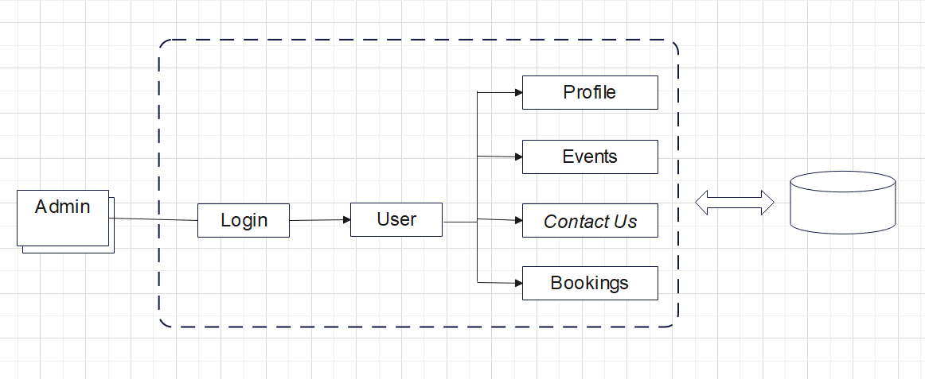

Fig.6.1.1 System Architecture

**6.2 UML DIAGRAMS :**

The Unified Modeling Language (UML) is a standard language for specifying, visualizing, constructing, and documenting the artifacts of software systems, as well as for business modeling and other non-software systems. The UML represents a collection of best engineering practices that have proven successful in the modeling of large and complex systems. The UML is a very important part of developing objectsoriented software and the software development process. The UML uses mostly graphical notations to express the design of software projects. Using the UML helps project teams communicate, explore potential designs, and validate the architectural design of the software.

**6.2.1 USER USE CASE DIAGRAM :**

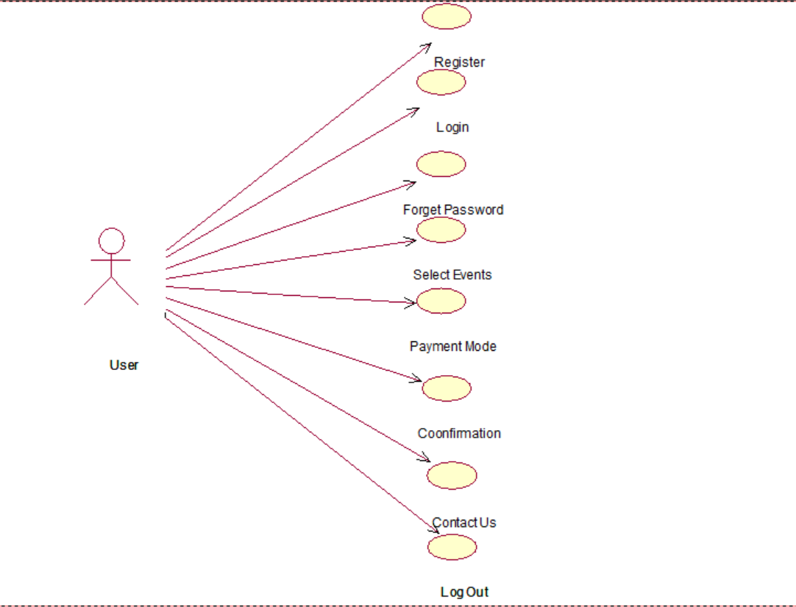

Fig.6.2.1 User Use Case Diagram

**6.2.2 ADMIN USE CASE DIAGRAM :**

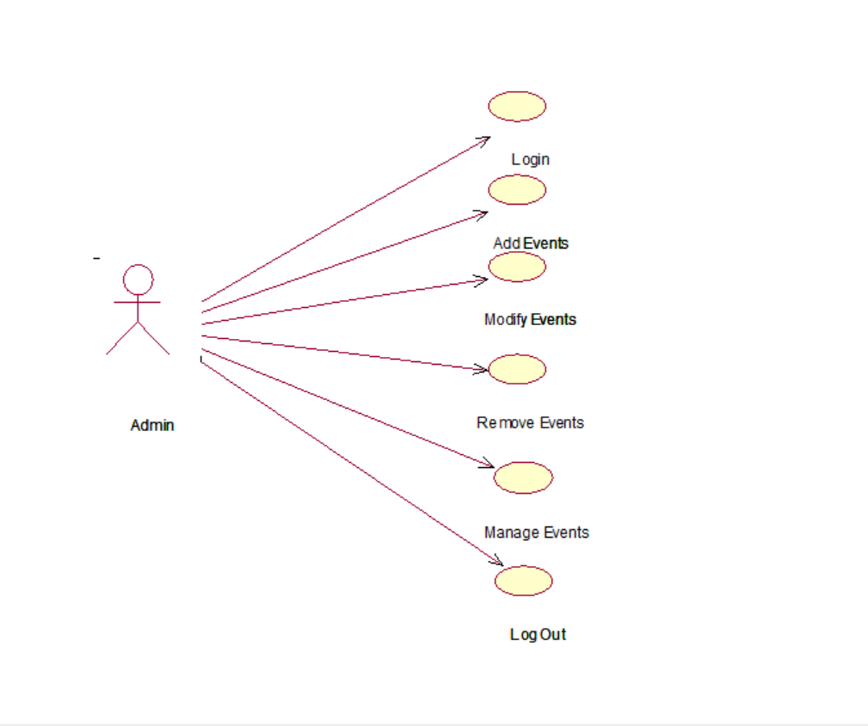

Fig.6.2.2 Admin Use Case Diagram

**6.2.3 CLASS DIAGRAM :**

The class diagram is used to refine the use case diagram and define a detailed design of the system. The class diagram classifies the actors defined in the use case diagram into a set of interrelated classes. The relationship or association between the classes can be either an "is-a" or "has-a" relationship. Each class in the class diagram may be capable of providing certain functionalities. These functionalities provided by the class are termed "methods" of the class. Apart from this, each class may have certain "attributes" that uniquely identify the class.

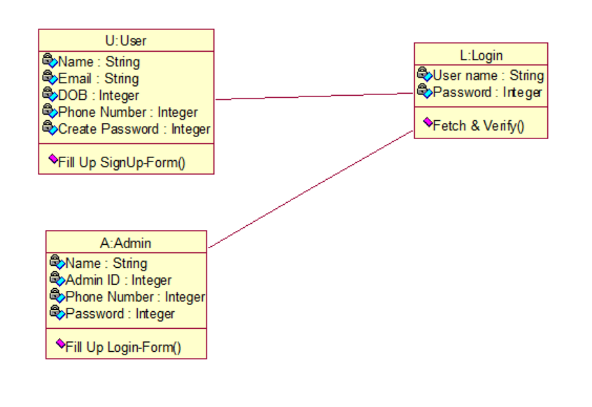

Fig.6.2.3 Class Diagram

**6.2.4 SEQUENCE DIAGRAM :**

A sequence diagram represents the interaction between different objects in the system. The important aspect of a sequence diagram is that it is timeordered. This means that the exact sequence of the interactions between the objects is represented step-by-step. Different objects in the sequence diagram interact with each other by passing "messages".

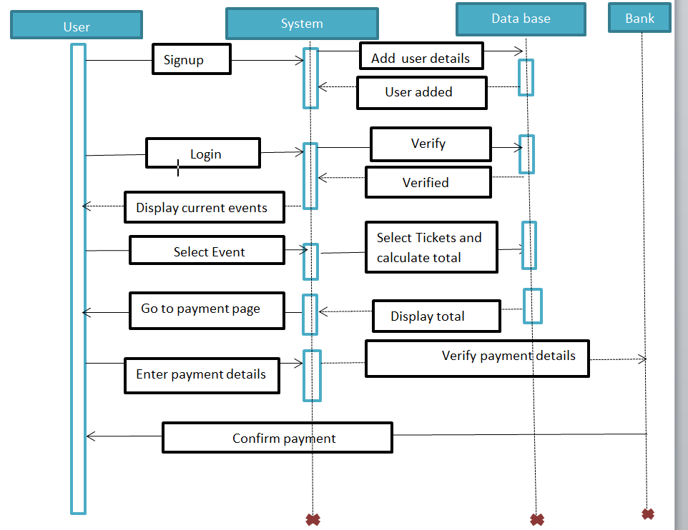

Fig.6.2.4 Sequence Diagram

**6.2.5 ACTIVITY DIAGRAM :**

Activity diagrams are graphical representation of workflows of stepwise activities and actions with support for choice, iteration and concurrency. In the Unified Modelling Language, activity diagrams can be used to describe the business and operational step-by-step workflows of components in a system. An activity diagram shows the overall flows of control. In the following Figure control flow between Admin, Application and Faculty. Faculty or Admin can login with respective credentials.

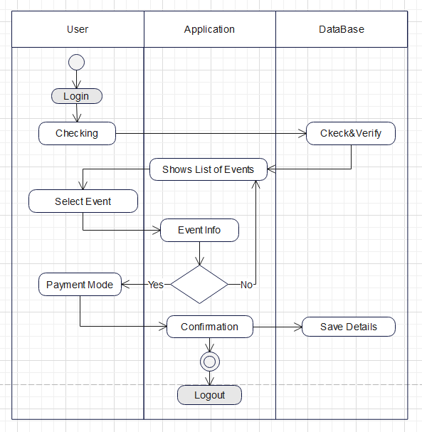

Fig.6.2.5 Activity Diagram

**6.3 DATA FLOW DIAGRAM :**



A Data Flow Diagram (DFD) is a traditional visual representation of the information flows within a system. A neat and clear DFD can depict the right amount of the system requirement graphically. It can be manual, automated, or a combination of both. It shows how data enters and leaves the system, what changes the information, and where data is stored.

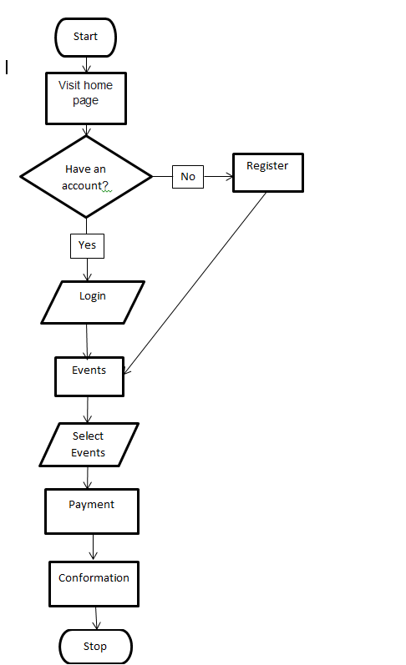

Fig.6.3.1 Flow Diagram

**CHAPTER - 7**

**SYSTEM IMPLEMENTATION**

**7. SYSTEM IMPLEMENTATION**

**7.1 PROJECT MODULES :**

* + - Home Page
    - Registration Page
    - Login Page
    - Events Page
    - Work Shops
    - Sponsors Page
    - About Us
    - Contact Us
    - Students
    - Ticket Page
    - Index
    - DB_Connect
    - Payment

**7.2 SOURCE CODE :**

**7.2.1 Home Page :**

<?php include('server.php') ?>

<!DOCTYPE html>

<html>

<head>

    <meta charset="utf-8">

    <meta name="viewport" content="width=device-width, initial-scale=1.0">

    <link rel="stylesheet" href="HomePage.css">

    <link rel="preconnect" href="https://fonts.gstatic.com">

    <link rel="stylesheet" href="https://cdnjs.cloudflare.com/ajax/libs/font-awesome/5.15.2/css/all.min.css">

<script src="https://cdnjs.cloudflare.com/ajax/libs/jquery/3.6.0/jquery.min.js"></script>

    <script src="https://ajax.googleapis.com/ajax/libs/jquery/3.5.1/jquery.min.js"></script>

    <script src="//cdn.jsdelivr.net/npm/sweetalert2@11"></script>

    <script src="https://maxcdn.bootstrapcdn.com/bootstrap/3.4.1/js/bootstrap.min.js"></script>

    <link rel="stylesheet" href="sweetalert2.min.css">

    <script src="bower_components/sweetalert2/dist/sweetalert2.min.js"></script>

    <link rel="stylesheet" href="bower_components/sweetalert2/dist/sweetalert2.min.css">

    <script src="jquery-3.6.0.min.js"></script>

    <script src="sweetalert2.all.min.js"></script>

    <style>

        .swal-text {

           background-color: rgba(59, 3, 59);

                padding: 10px;

                border: 1px solid whitesmoke;

                display: block;

                margin: 10px;

                text-align: center;

                color: whitesmoke !important;

                font-family: 'Courier New',monospace !important;

           /*text-align: center;

           color:purple !important;*/

                font-size:12px;

}

        </style>

    <header>

    <div id="menu" class="fas fa-bars"></div>

    <a href="HomePage.php" class="logo">FESTNEST</a>

<nav class="navbar">

        <ul>

           <li><a class="active" href="HomePage.php">Home</li>

           <li><a href="About us.html">About Us</a></li>

           <li><a href="Contact us.php">Contact Us</a></li>

           <li><a href="Sponsors.html">Sponsors</a></li>

           <li><a href="Gallery.html">Gallery</a></li>

        </ul>

    </nav>

    <div id="login" class="fas fa-user-circle"></div>

   </header>

</head>

<body>

   <div class="banner">

        <video autoplay loop muted>

            <source src="11 EXO 2.mp4" type="video/mp4">

        </video>

        <h1 id="logo">FESTNEST</h1>

        <p>Let's enjoy together!</p>

        <a id="bt2" style="position:absolute; bottom: 7%;"><button class="btn">Get Started Here!</button>

        </a>

    </div>

<div class="login-form">

<!-- <div id="id_confrmdiv" style="display: none;" >INPUT FIELD IS EMPTY! <button

id="id_truebtn">OK</button>

**7.2.2 Registration Page :**

<?php include('server.php') ?>

<!DOCTYPE html>

<html>

<head>

    <meta charset="utf-8">

        <meta name="viewport" content="width=device-width, initial-scale=1">

    <title>Registration Form</title>

    <link rel="stylesheet" type="text/css" href="Registration.css">

     <link rel="stylesheet"

             href="https://cdnjs.cloudflare.com/ajax/libs/animate.css/4.1.1/animate.min.css"/>

     <link rel="preconnect" href="https://fonts.gstatic.com">

     <link rel="stylesheet" href="https://cdnjs.cloudflare.com/ajax/libs/font-awesome/5.15.2/css/

     all.min.css">

      <script src="sweetalert2.all.min.js"></script>

        <script src="//cdn.jsdelivr.net/npm/sweetalert2@11"></script>

      <link rel="stylesheet" href="https://maxcdn.bootstrapcdn.com/bootstrap/3.4.1/css/bootstrap.min.css">

      <script src="https://ajax.googleapis.com/ajax/libs/jquery/3.5.1/jquery.min.js"></script>

<script src="https://maxcdn.bootstrapcdn.com/bootstrap/3.4.1/js/bootstrap.min.js"></script>

      <script src="bower_components/sweetalert2/dist/sweetalert2.min.js"></script>

<link rel="stylesheet" href="bower_components/sweetalert2/dist/sweetalert2.min.css">

<!-- Include a polyfill for ES6 Promises (optional) for IE11 and Android browser -->

<script src="https://cdnjs.cloudflare.com/ajax/libs/core-js/2.4.1/core.js"></script>

  <script src="jquery-3.6.0.min.js"></script>

</head>

<body>

   <div id="fset">

   <form action="<?php echo htmlspecialchars($_SERVER['PHP_SELF']) ?>" method="POST" id="regform"

    onsubmit="return checksame()">

    <?php include('errors.php'); ?>

    <h1>Enter your details here!</h1>

        <input type="text" id="username" name="username" placeholder="Username" >

        <input type="text" id="name" name="name" placeholder="Full Name">

        <input type="email" id="email" name="email" placeholder="Email" >

             <input type="number" id="phno" name="phno" placeholder="Phone number" >

             <input type="text" id="college" name="college" placeholder="College">

             <input type="password" id="password" name="password" placeholder="Password" pattern="

             (?=.*\d) (?=.*[a-z])(?.*[A-Z]).(8,}"

title="Must contain at least one number and one uppercase and lowercase letter, and at least 8 or more characters">

             <input type="password" id="repassword" name="repassword" placeholder="Confirm password" >

             <center>

               <div id="cbfull">

               <input type="checkbox"id="cb" onclick="myFunction()">Show Password<br>

               <label>

               <input type="checkbox" name="remember" id="cb" value="Remember me" <?php if(isset($_COOKIE["Rmember_login"])) { ?> checked <?php } ?> />

 Remember me</label>

               </div>

               </center>

               <center><button id="newcb" type="submit" name="register" style="cursor: pointer;">REGISTER!</button></center>

   </form>

   <br>

   <center style="font-size:15px; color: rgb(59,3,59);">Login Instead?<a href="HomePage.php"> <div style="align-items: center !important; color: whitesmoke; font-size: 15px;">Click here!</div></a></center>

</div>

    <div id="message">

        <h3>Password must contain the following:</h3>

        <p id="letter" class="invalid">A <b>lowercase</b> letter</p>

        <p id="capital" class="invalid">A <b>capital(uppercase)</b> letter</p>

        <p id="number" class="invalid">A <b>number</b></p>

        <p id="length" class="invalid">Minimum <b>8 characters</b></p>

</div>

    <script>

         function myFunction() {

            var x = document.getElementById("password");

            if (x.type === "password") {

                x.type="text";

            } else {

                x.type ="password";

            }

            var y = document.getElementById("repassword");

            if (y.type === "password") {

                  y.type = "text";

            } else {

                y.type = "password"

}

        }

          var myInput = document.getElementById("password");

          var letter = document.getElementById("letter");

          var capital = document.getElementById("capital");

          var number = document.getElementById("number");

          var length = document.getElementById("length");

          // When the user clicks on the password field, show the message box

           myInput.onfocus = function() {

              document.getElementById("message").style.display = "block";

            }

          // When the user clicks outside of the password field, hide the message box

           myInput.onblur = function() {

             document.getElementById("message").style.display = "none";}

// When the user starts to type something inside the password field

          myInput.onkeyup = function() {

            // Validate lowercase letters

            var lowerCaseLetters = /[a-z]/g;

            if(myInput.value.match(lowerCaseLetters)) {

                letter.classList.remove("invalid");

                letter.classList.add("valid");

            } else {

                letter.classList.remove("valid");

**7.2.3 Events Page :**

<?php

include 'auth.php';

include "admin/includes/config.php";

?>

<!DOCTYPE html>

<html lang="en">

<head>

    <meta charset="UTF-8">

    <meta name="description" content="">

    <meta http-equiv="X-UA-Compatible" content="IE=edge">

    <meta name="viewport" content="width=device-width, initial-scale=1, shrink-to-fit=no">

    <!-- Title -->

    <title>Festnest</title>

    <!-- Favicon -->

    <link rel="icon" href="./img/core-img/favicon.png">

    <!-- Stylesheet -->

    <link rel="stylesheet" href="style.css">

    <style>

html {

            scroll-behavior: smooth;

        }

    </style>

</head>

<body>

    <!-- Preloader -->

    <div id="preloader">

        <div class="loader"></div>

    </div>

    <!-- /Preloader -->

    <!-- Header Area Start -->

    <header class="header-area">

        <div class="classy-nav-container breakpoint-off">

            <div class="container">

                <!-- Classy Menu -->

                <nav class="classy-navbar justify-content-between" id="conferNav">

                    <!-- Logo -->

                    <a class="nav-brand" href="./index.php">FESTNEST</a>

                    <!-- Navbar Toggler -->

                    <div class="classy-navbar-toggler">

                        <span class="navbarToggler"><span></span><span></span><span></span></span>

                    </div>

                    <!-- Menu -->

                    <div class="classy-menu">

                        <!-- Menu Close Button -->

                        <div class="classycloseIcon">

<div class="cross-wrap"><span class="top"></span><span class="bottom"></span></div>

                        </div>

                        <!-- Nav Start -->

                        <div class="classynav">

                            <ul id="nav">

                                <li ><a href="index.php">Home</a></li>

                                <li><a href="#about">About Us</a></li>

                                <li class="active"><a href="events.php">Events</a></li>

                                <li><a href="workshops.php">Workshops</a></li>

                                <li><a href="#sponsor">Sponsors</a></li>

                                <li><a href="#contact">Contact Us</a></li>

</ul>

                            <!-- Get Tickets Button -->

                            <?

                            if($_SESSION==''){

                            ?>

                            <a href="login.php" class="btn confer-btn mt-3 mt-lg-0 ml-3 ml-lg-5">Login <i class="zmdi zmdi-long-arrow-right"></i></a>

                            <? } else { ?>

                                <a href="logout.php" class="btn confer-btn mt-3 mt-lg-0 ml-3 ml-lg-5">Logout <i class="zmdi zmdi-long-arrow-right"></i></a>

                                <? } ?>

                        </div>

                        <!-- Nav End -->

                    </div>

</nav>

            </div>

        </div>

    </header>

    <!-- Header Area End -->

    <section class="breadcrumb-area bg-img bg-gradient-overlay jarallax" style="background-image: url(img/bg-img/17.jpg);">

        <div class="container h-100">

            <div class="row h-100 align-items-center">

                <div class="col-12">

                    <div class="breadcrumb-content">

                        <h2 class="page-title">Events</h2>

                        <nav aria-label="breadcrumb">

                            <ol class="breadcrumb">

**7.2.4 Workshops Page :**

<?php

include 'auth.php';

include "admin/includes/config.php";

?>

<!DOCTYPE html>

<html lang="en">

<head>

    <meta charset="UTF-8">

    <meta name="description" content="">

    <meta http-equiv="X-UA-Compatible" content="IE=edge">

    <meta name="viewport" content="width=device-width, initial-scale=1, shrink-to-fit=no">

    <!-- Title -->

    <title>Festnest</title>

<!-- Favicon -->

    <link rel="icon" href="./img/core-img/favicon.png">

    <!-- Stylesheet -->

    <link rel="stylesheet" href="style.css">

    <style>

        html {

            scroll-behavior: smooth;

        }

    </style>

</head>

<body>

    <!-- Preloader -->

    <div id="preloader">

        <div class="loader"></div>

    </div>

    <!-- /Preloader -->

    <!-- Header Area Start -->

    <header class="header-area">

        <div class="classy-nav-container breakpoint-off">

            <div class="container">

                <!-- Classy Menu -->

                <nav class="classy-navbar justify-content-between" id="conferNav">

                    <!-- Logo -->

                    <a class="nav-brand" href="./index.php">FESTNEST</a>

                    <!-- Navbar Toggler -->

                    <div class="classy-navbar-toggler">

                        <span

class="navbarToggler"><span></span><span></span><span></span></span>

                    </div>

                    <!-- Menu -->

                    <div class="classy-menu">

                        <!-- Menu Close Button -->

                        <div class="classycloseIcon">

                            <div class="cross-wrap"><span class="top"></span><span class="bottom"></span></div>

                        </div>

                        <!-- Nav Start -->

                        <div class="classynav">

                            <ul id="nav">

                                <li ><a href="index.php">Home</a></li>

                                <li><a href="#about">About Us</a></li>

                                <li ><a href="events.php">Events</a></li>

                                <li class="active"><a href="workshops.php">Workshops</a></li>

                                <li><a href="#sponsor">Sponsors</a></li>

                                <li><a href="#contact">Contact Us</a></li>

</ul>

                            <!-- Get Tickets Button -->

                            <?

                            if($_SESSION==''){

                            ?>

                            <a href="login.php" class="btn confer-btn mt-3 mt-lg-0 ml-3 ml-lg-5">Login <i class="zmdi zmdi-long-arrow-right"></i></a>

                            <? } else { ?>

                                <a href="logout.php" class="btn confer-btn mt-3 mt-lg-0 ml-3 ml-lg-5">Logout <i class="zmdi zmdi-long-arrow-

right"></i></a>

                                <? } ?>

                        </div>

                        <!-- Nav End -->

                    </div>

                </nav>

            </div>

        </div>

    </header>

    <!-- Header Area End -->

    <section class="breadcrumb-area bg-img bg-gradient-overlay jarallax" style="background-image: url(img/bg-img/17.jpg);">

        <div class="container h-100">

            <div class="row h-100 align-items-center">

                <div class="col-12">

                    <div class="breadcrumb-content">

                        <h2 class="page-title">Workshops</h2>

                        <nav aria-label="breadcrumb">

                            <ol class="breadcrumb">

                                <li class="breadcrumb-item"><a href="index.html">Home</a></li>

<li class="breadcrumb-item active" aria-current="page">Workshops</li>

</ol>

                        </nav>

                    </div>

                </div>

            </div>

        </div>

    </section>

    <!-- Our Schedule Area Start -->

    <section class="our-schedule-area bg-white section-padding-100">

<div class="container">

            <div class="row">

                <div class="col-12">

                    <!-- Tab Content -->

                    <div class="tab-content" id="conferScheduleTabContent">

                        <div class="tab-pane fade show active" id="step-one" role="tabpanel" aria-labelledby="monday-tab">

                            <!-- Single Tab Content -->

                            <div class="single-tab-content">

                                <div class="row">

                                    <div class="col-12">

                                        <?

                                            $result=$con->query("SELECT * FROM `workshop` where workshop_status=1 ORDER BY `workshop_id` ASC");

                                            $j=1;

                                            while($row = mysqli_fetch_assoc($result)) {

                                       ?>

**7.2.5 About Us :**

<!DOCTYPE html>

<html>

  <head>

    <meta charset="utf-8">

  <meta name="viewport" content="width=device-width, initial-scale=1.0" >

  <script src="https://cdnjs.cloudflare.com/ajax/libs/jquery/3.6.0/jquery.min.js"></script>

  <script>

$(document).ready(function(){

    $('#menu').click(function(){

        $(this).toggleClass('fa-times');

        $('.navbar').toggleClass("nav-toggle");

    });

    $(window).on('load scroll',function(){

         $('#menu').removeClass('fa-times');

         $('.navbar').removeClass('nav-toggle');

         $('.login-form').removeClass('popup');

         });

    });

    </script>

<link rel="stylesheet" href="https://cdnjs.cloudflare.com/ajax/libs/font-awesome/5.15.2/css/all.min.css">

<link rel="stylesheet" href="https://stackpath.bootstrapcdn.com/bootstrap/4.4.1/css/bootstrap.min.css" integrity="sha384-Vkoo8x4CGs03+Hhxv8T/Q5Paxtkktu6ugSTOеNV6g81FeWPGFN9Muh0f23091fjh" crossorigin= "anonymous">

     <style>

:root

{

--gradient: Linear-gradient( #6e538d.rgb(71,78,93));

}

    *

    {

          margin: 0;

          padding: 0;

          box-sizing: border-box;

          border: none;

outline: none;

          text-decoration: none;

          transition: all .2s Linear;

    }

    *

    ::selection {

       background: rgb(65, 2, 46);

       color: #fff;

}

html{

   overflow-x: hidden;

}

html::-webkit-scrollbar

{

    width: 1rem;

}

html::-webkit-scrollbar-track{

     background: rgba(202, 199, 199, 0.199);

}

html::-webkit-scrollbar-thumb{

      background: Linear-gradient(#6e538d,#3d0642);

      padding: 1.5rem 7%;

      background: var(--gradient);

      box-shadow:0 .1rem .3rem rgba(0,0,0,.3);

**7.2.6 Contact Us :**

<?php

session_start();

$errors = array();

include 'admin/db_connect.php';

$q="select * from system_settings where id=1";

$res=mysqli_query($conn, $q);

if ($x=$res->fetch_assoc()) {

$_SESSION['contact']=$x['contact'];

$_SESSION['email']=$x['email']; }

?>

<!DOCTYPE html>

<html>

<head>

<meta charset="utf-8">

    <meta name="viewport" content="width=device-width, initial-scale=1.0">

    <script src="https://cdnjs.cloudflare.com/ajax/libs/jquery/3.6.0/jquery.min.js"></script>

<link rel="stylesheet" href="https://cdnjs.cloudflare.com/ajax/libs/font-awesome/5.15.2/css/all.min.css">

<link rel="stylesheet" href="https://stackpath.bootstrapcdn.com/bootstrap/4.4.1/css/bootstrap.min.css" integrity="sha384-Vkoo8x4CGs03+Hhxv8T/Q5PaXtkktuбugSTOeNV6gBiFeWPGFN9Muhof23091fjh" crossorigin="anonymous">

<style>

:root

{

    --gradient: Linear-gradient(90deg, #6e538d, #3d0642);

}

*

{

     margin: 0;

     padding: 0;

 box-sizing: border-box;

     border: none;

     outline: none;

     text-decoration: none;

     transition: all .2s Linear;

}

* ::selection

{

     background: rgb(65, 2, 46);

  color: #fff;

}

html

{

     font-size: 62.5%;

     overflow-x: hidden;

}

html::-webkit-scrollbar

{

     width: 1.5rem;

}

html::-webkit-scrollbar-track

{

     background: rgba(202, 199, 199, 0.199);

}

html::-webkit-scrollbar-thumb

{

     background: Linear-gradient(#6e538d, #3d0642);

}

section

{

     min-height: 100vh;

padding: 1rem 7%;

     padding-top: 6rem;

}

header

{

     width: 100%;

     display: flex;

     align-items: center;

     justify-content: space-between;

     position: fixed;

top: 0;

     Left: 0;

     z-index: 1000;

     padding: 1.5rem 7%;

     background: var(--gradient);

     box-shadow: 0.1rem .3rem rgba(0,0,0,.3);

     height:50px;

}

header .logo

{

     color: #fff;

     font-size: 2.5rem;

}

header .navbar ul

{

     display: flex;

     align-items: center;

     font-size: 2rem;

     color: #fff;

}

header .navbar ul li a.active,

header .navbar ul li a:hover

{

     color: rgb(132, 219, 241);

     text-decoration:none;

}

header #logo:hover

{

     color: rgb(132, 219, 241);

     text-decoration:none;

}

header #menu

{

     font-size: 3rem;

     color:#fff ;

     cursor: pointer;

     display: none;

}

.home

{

     display: flex;

     align-items: center;

     justify-content: center;

**Database:**

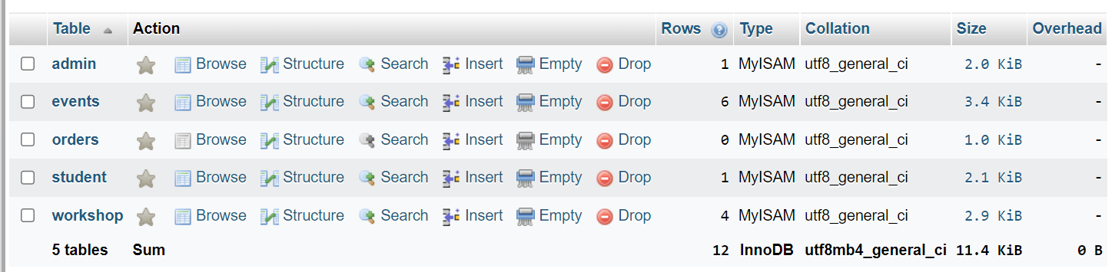

**Admin Database :**

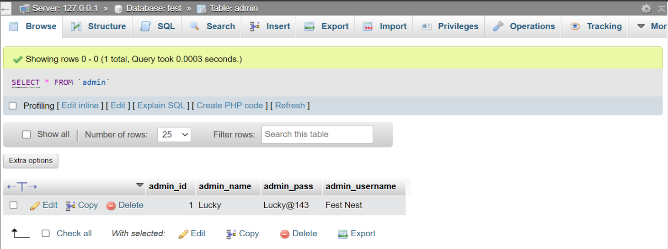

**Events Database :**

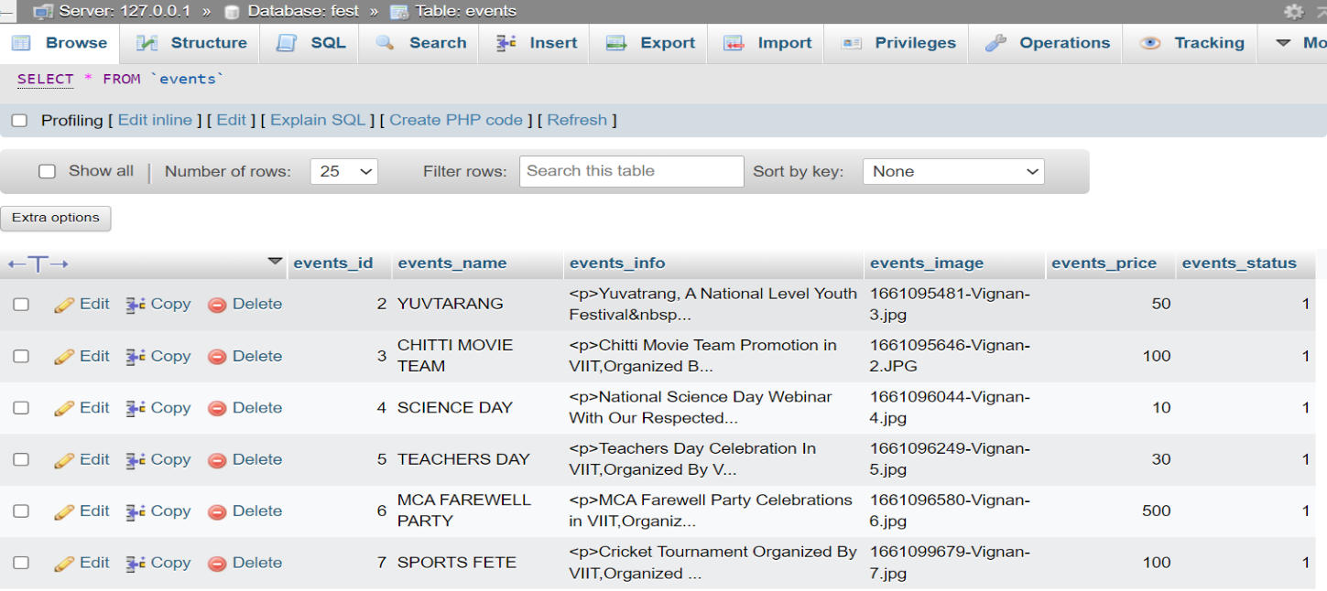

**Orders Database :**

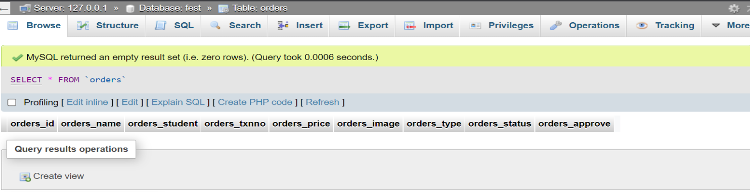

**Workshop Database :**

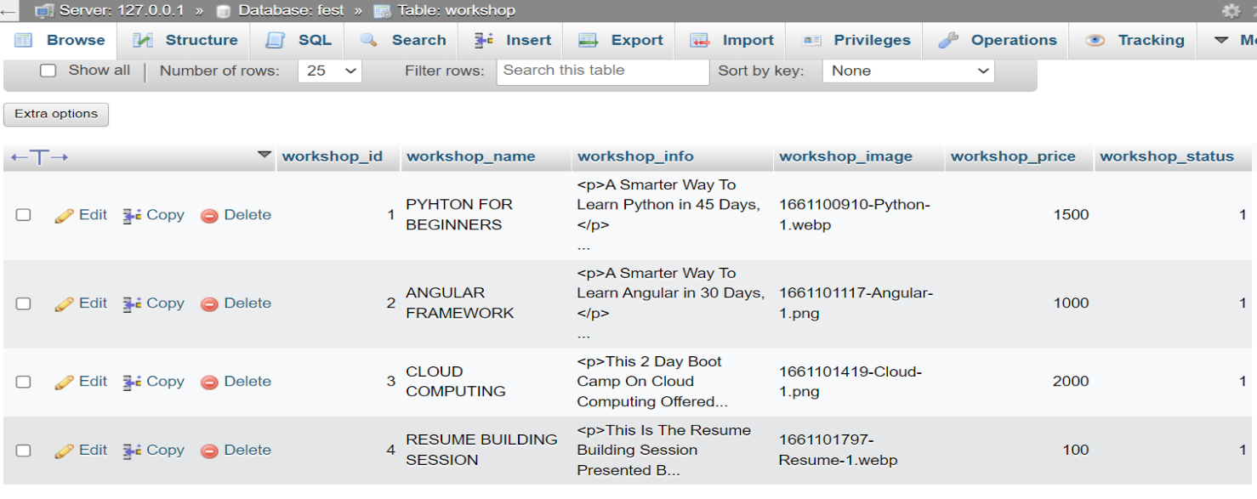

**Students Database :**

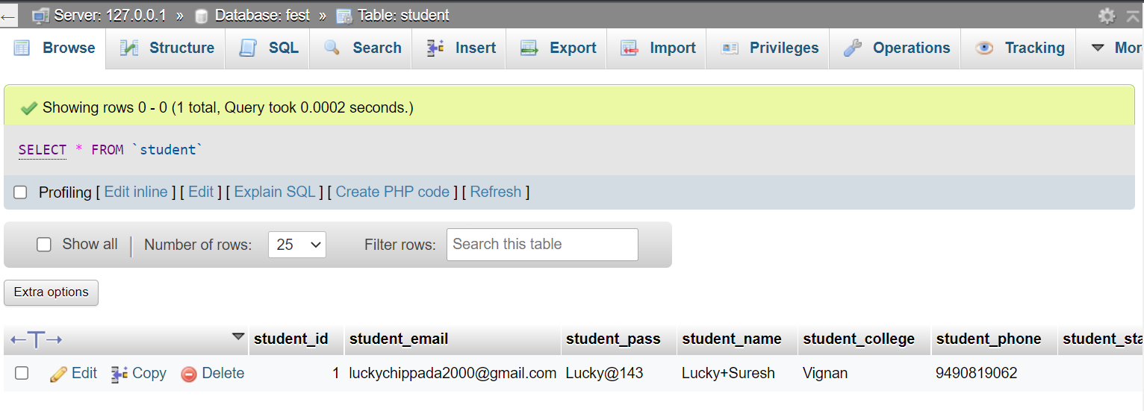

**CHAPTER – 8**

**SYSTEM TESTING**

**8. SYSTEM TESTING**

System Testing means testing the system. All the modules/components are integrated in order to verify if the system works as expected or not. System Testing is done after Integration Testing. This plays an important role in delivering a high-quality product.

**8.1 Testing Methods :**

**8.1.1 Unit Testing :**

Unit testing involves the design of test cases that validate that the internal program logic is functioning properly, and that program inputs produce valid outputs. All decision branches and internal code flow should be validated. It is the testing of individual software units of the application. It is done after the completion of an individual unit before integration. This is a structural testing, that relies on knowledge of its construction and is invasive. Unit tests perform basic tests at component level and test a specific business process, application, and/or system configuration. Unit tests ensure that each unique path of a business process performs accurately to the documented specifications and contains clearly defined inputs and expected results.

**8.1.2 Integration Testing :**

Integration tests are designed to test integrated software components of Employee Details like Events, Publications, Certifications, Student Counselling, Project Guidance are actually run as one program. Testing is event driven and is more concerned with the basic outcome of screens or fields. Integration tests demonstrate that although the components were individually satisfaction, as shown by successfully unit testing, the combination of components is correct and consistent. Integration testing is specifically aimed at exposing the problems that arise from the combination of components.

**8.1.3 Functional Testing :**

Functional tests provide systematic demonstrations that functions tested are available as specified by the business and technical requirements, system documentation, and user manuals.

Functional testing is centered on the following items :

Valid Input : Identified classes of valid input must be accepted.

Ex : only Pdf Should be given in pdf format field.

Invalid Input : identified classes of invalid input must be rejected.

Ex : if you give a jpeg/jpg in the pdf format field.

Functions : identified functions must be exercised.

Output : identified classes of application outputs must be exercised.

Systems/Procedures : interfacing systems or procedures must be invoked

Organization and preparation of functional tests is focused on requirements, key functions, or special test cases. In addition, systematic coverage pertaining to identify Business process flows; data fields, predefined processes, and successive processes must be considered for testing. Before functional testing is complete, additional tests are identified and the effective value of current tests is determined.

**8.1.4 System Testing :**

System testing ensures that the entire integrated software system meets requirements. It tests a configuration to ensure known and predictable results. An example of system testing is the configuration-oriented system integration test. System testing is based on process descriptions and flows, emphasizing pre-driven process links and integration points.

**8.1.5 White Box Testing :**

White Box Testing is a testing in which the software tester has knowledge of the inner workings, structure and language of the software, or at least its purpose. It is purpose. It is used to test areas that cannot be reached from a black box level.

**8.1.6 Black Box Testing :**

Black Box Testing is testing the software without any knowledge of the inner workings, structure or language of the module being tested. Black box tests, as most other kinds of tests, must be written from a definitive source document, such as specification or requirements document, such as specification or requirements document. It is a testing in which the software under test is treated, as a black box. you cannot “see” into it. The test provides inputs and responds to outputs without considering how the software works.

**8.1.7 Test strategy and approach :**

Field testing will be performed manually and functional tests will be written in detail.

**8.1.8 Test Objectives :**

* + All field entries must work properly.
  + Pages must be activated from the identified link.
  + The entry screen, messages and responses must not be delayed.

**8.1.9 Features to be tested :**

• Verify that the entries are of the correct format.

• No duplicate entries should be allowed.

• All links should take the user to the correct page.

**8.2 Test Cases :**

|  |  |  |  |  |
| --- | --- | --- | --- | --- |
| **Test Case** | **Condition** | **Expected Output** | **Observed Output** | **Status** |
| Open Web Application | If SQL is unexpectedly shutdown browser display an error | WFMS homepage shouldn’t displayed | WFMS homepage shouldn’t displayed | Fail |
| Open Web Application | XAMPP Server Runs Without any problem | WFMS Homepage should displayed | WFMS Homepage should displayed | Pass |
| Login | If user details are not correct, display error message | Invalid Credentials | Invalid Credentials | Fail |
| Login | If User details are correct | User Successfully logs into the web application | User Successfully logs into the web-application | Pass |
| Add New User | If User already exists in the system, error message should display | Not Add new user | Not added new user | Fail |
| Add New User | If User not exists in the system | New User added successfully | New User added successfully | Pass |

**CHAPTER - 9**

**EXPERIMENTAL RESULTS**

**9. EXPERIMENTAL RESULTS**

**Home Page :**

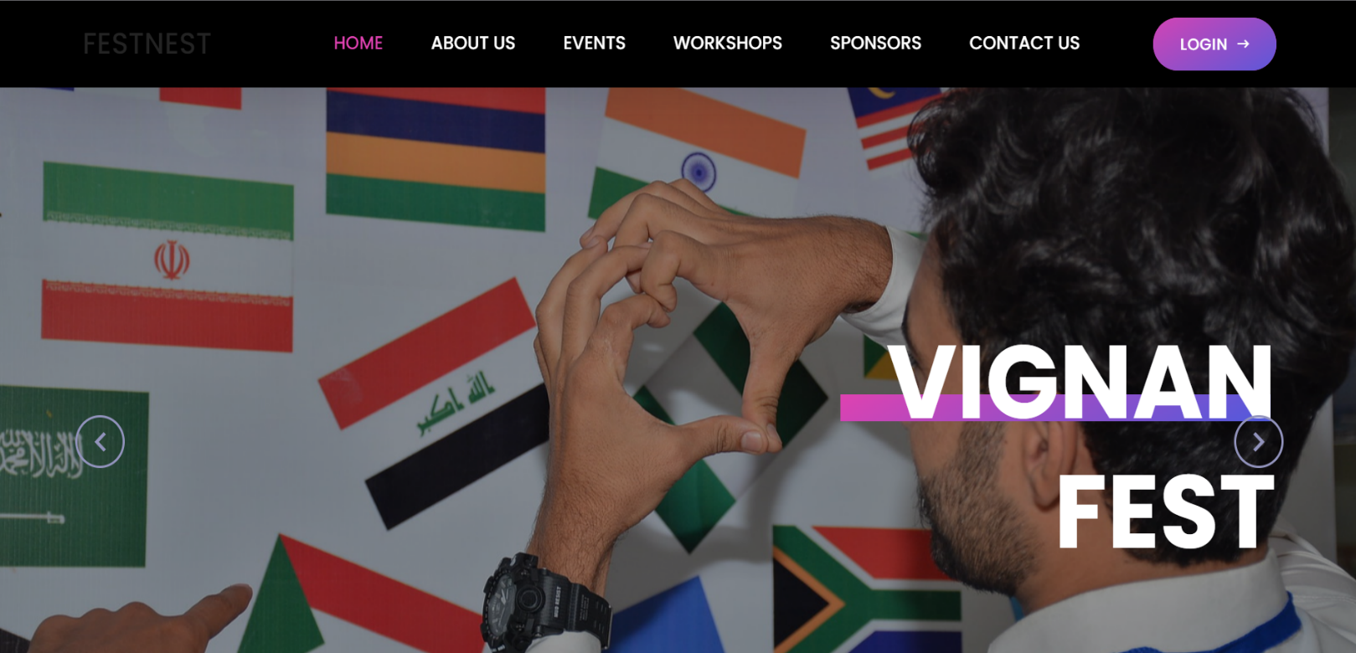

**Login Page:**

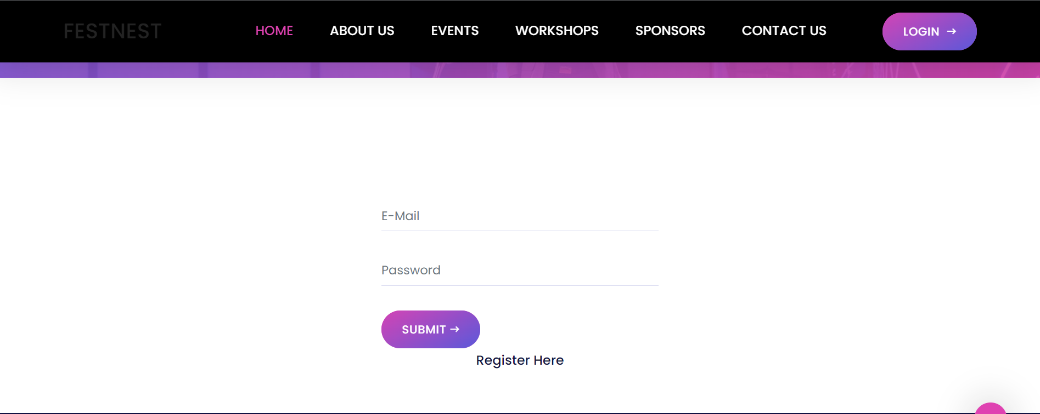

**Registration Page :**

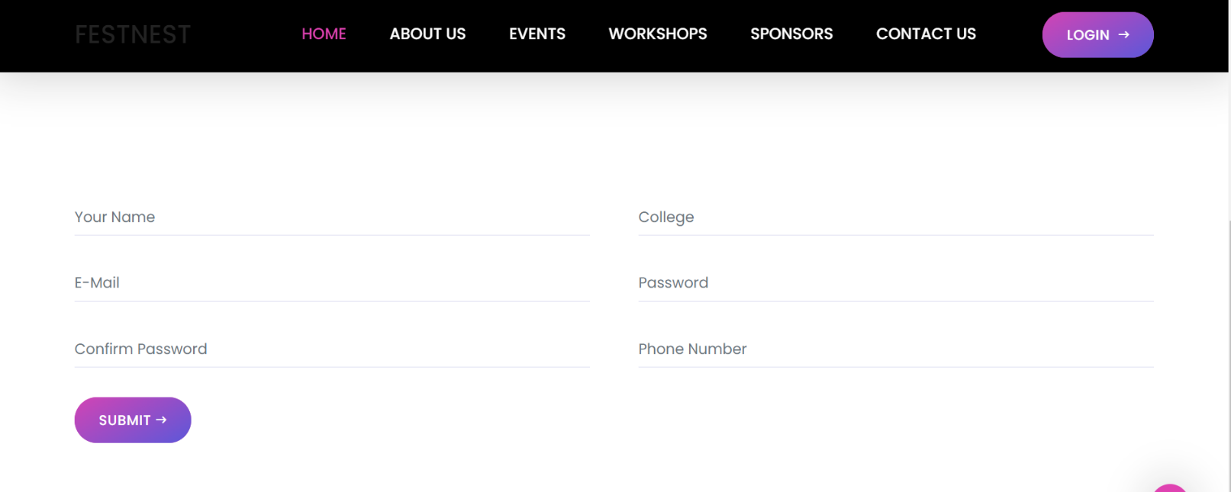

**Events Page:**

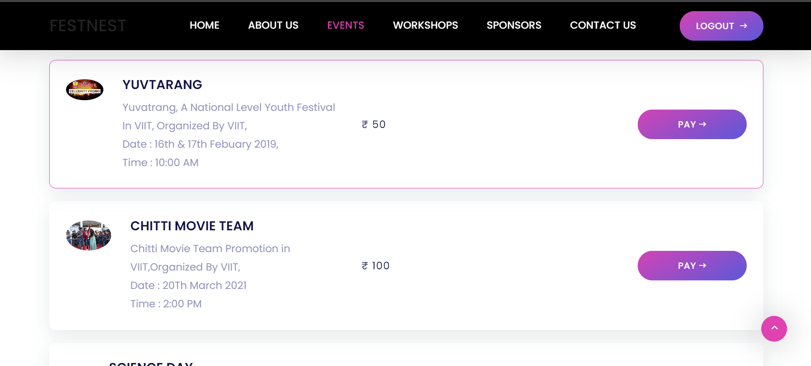

**Orders Page :**

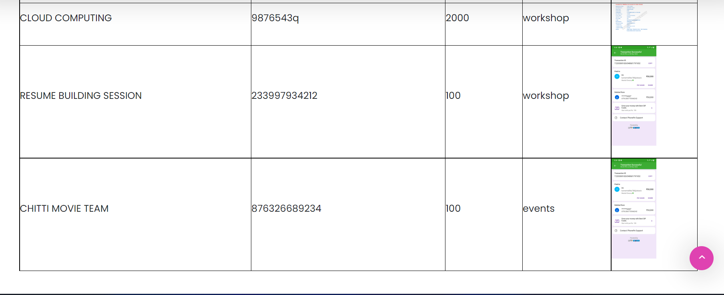

**Sponsors Page:**

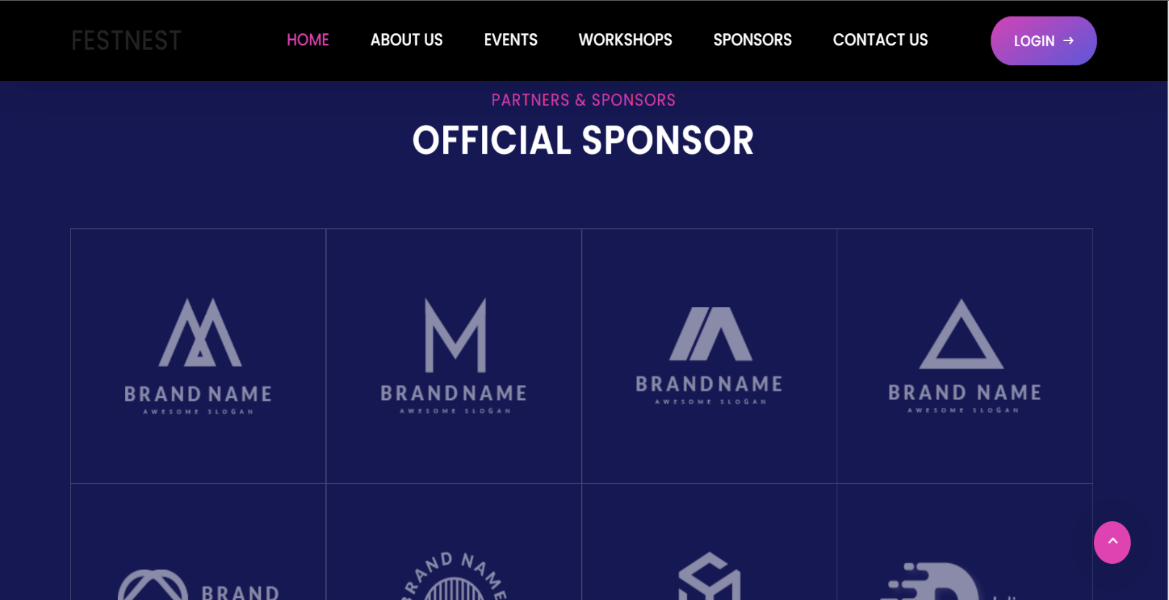

**Contact Us Page:**

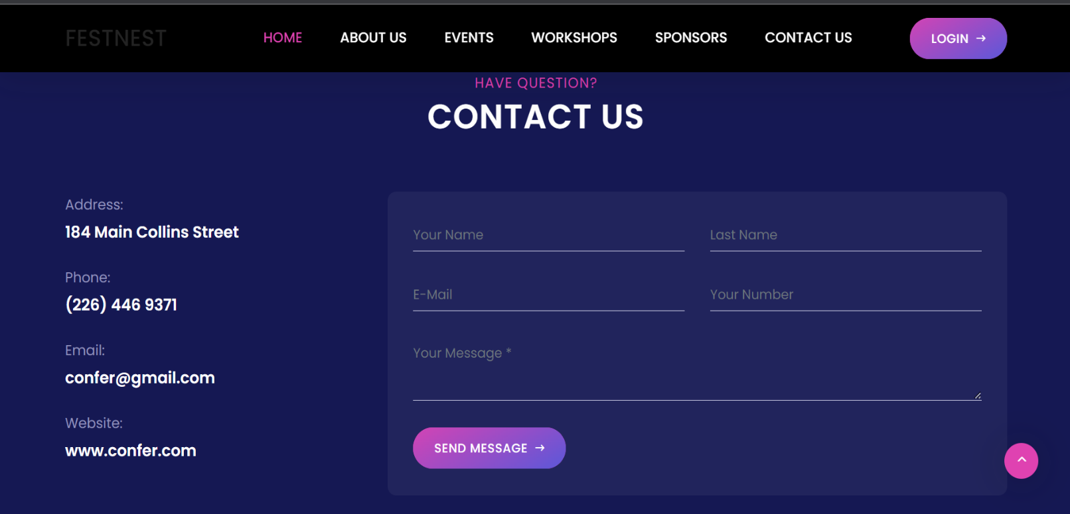

**Admin Login :**

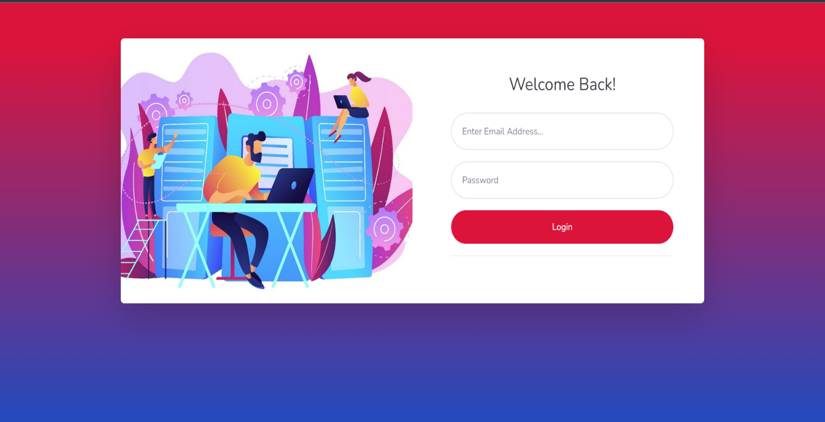

**Admin Side Events :**

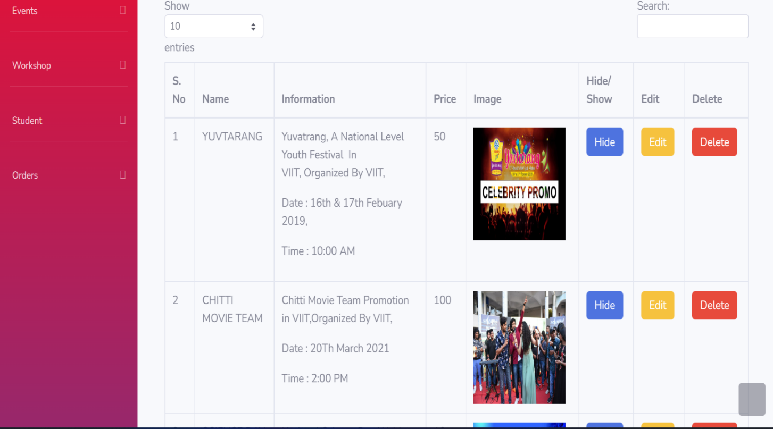

**Admin Side Workshops :**

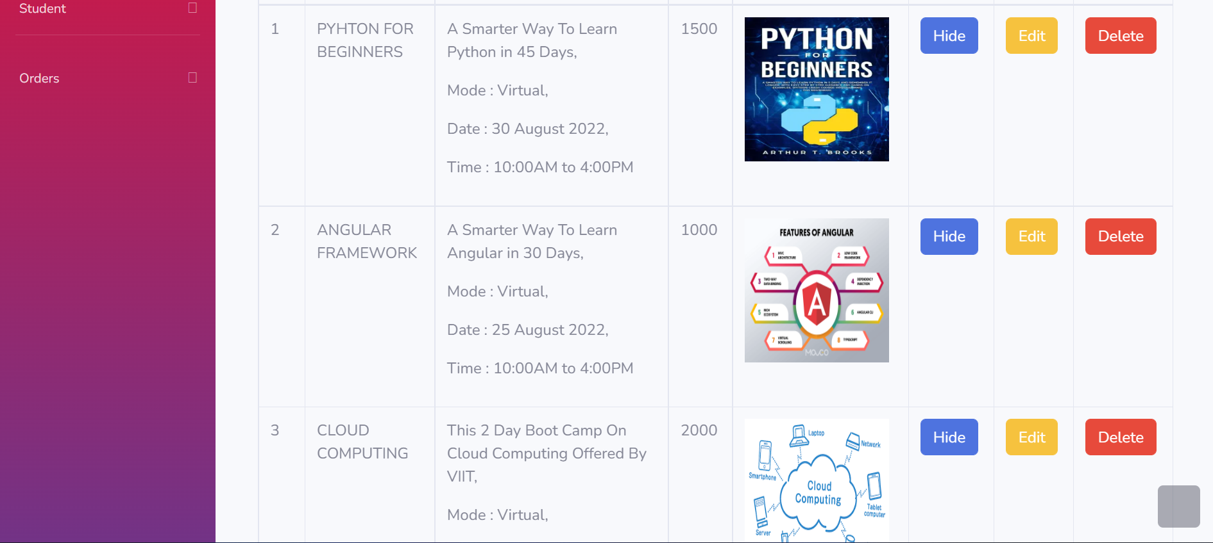

**CHAPTER - 10**

**CONCLUSION & FUTURE SCOPE**

**10. CONCLUSION & FUTURE SCOPE**

Having a clear idea about the event and getting a ticket for the event in VIGNAN is a difficult challenge for the people who want to attend the events(like fests, workshops etc.). It is due to a lack of accurate information about the event. Buying tickets on campus can be a difficult challenge for any individual without a proper concise.

As a result, we built FESTNEST, allowing individuals to book tickets online through the quick and easy website.

As for the future scope, we hope to work on it and improve it further to be used as on official website under VIGNAN, for all the 3 campuses.

**CHAPTER - 11**

**REFERENCES**

**11. REFERENCES**

* HTML5 : <https://html.spec.whatwg.org/>
* CSS3 : <https://developer.mozilla.org/en-US/docs/Learn/CSS>
* Bootstrap : <https://getbootstrap.com/>
* PHP : <https://www.w3schools.com/php/>
* MySQL : https://dev.mysql.com/doc/refman/8.0/en/tutorial.html



Plagiarism Checker X Originality Report

**Similarity Found: 9%**

Date: Thursday, October 20, 2022

Statistics: 682 words Plagiarized / 7903 Total words

Remarks: Low Plagiarism Detected - Your Document needs Optional Improvement.

-------------------------------------------------------------------------------------------

The project objective is to book events or fest tickets online. The FestNest is an Internet-based application that can be accessed throughout the Net and accessed by anyone who has a net connection. This application will reserve the tickets.

This online ticket reservation system provides a website for event organizers where any internet user can access it. The user must login to the system and needs a credit card/debit card/UPI for booking the tickets. The website provides complete information regarding currently running events with details of event timings, available seats. This newly designed website is a faster, cleaner, and more personal website, specially designed to make your booking experience better.

Logon, navigate and find out for yourselves, and if you are stuck somewhere or get doubts that must be cleared, we provided an option called Contact Us. Customers may view the contents of any event or fest at any time and may book any ticket as needed. The program automatically calculates the subtotal and grand total. When a visitor decides to finally book the ticket, the order information, including the buyer's name and billing instruction, is stored in the database securely, and payment has been made. You need to register a new user whenever you have first visited or site. Then in the future, it will be stored in our database permanently, and you can book the event tickets at any time you want with this username and password.